Round Table 4t May 2017

Woodberry Down S106 Contributions

- Purpose
This paper proposes a strategy for the allocation of s106 funds and the approval of specific projects to secure these funds.
- Background
A total in excess of £25 million has been approved in S106 contributions for Woodberry Down. This covers various areas from improvements to highways to the provision of community facilities. Each of the S106 Agreements defines where the monies are to be allocated.
- Current Position
The Council has received payments from Berkeley Homes totalling £6,576,028 of which £1,849,358 has been allocated. An additional £1.2 million is anticipated from phases currently on site. A further £18.5 million is expected from future phases 3-8.
The table below illustrates the current position, these figures have been updated and confirmed with the Development Contributions Officer.
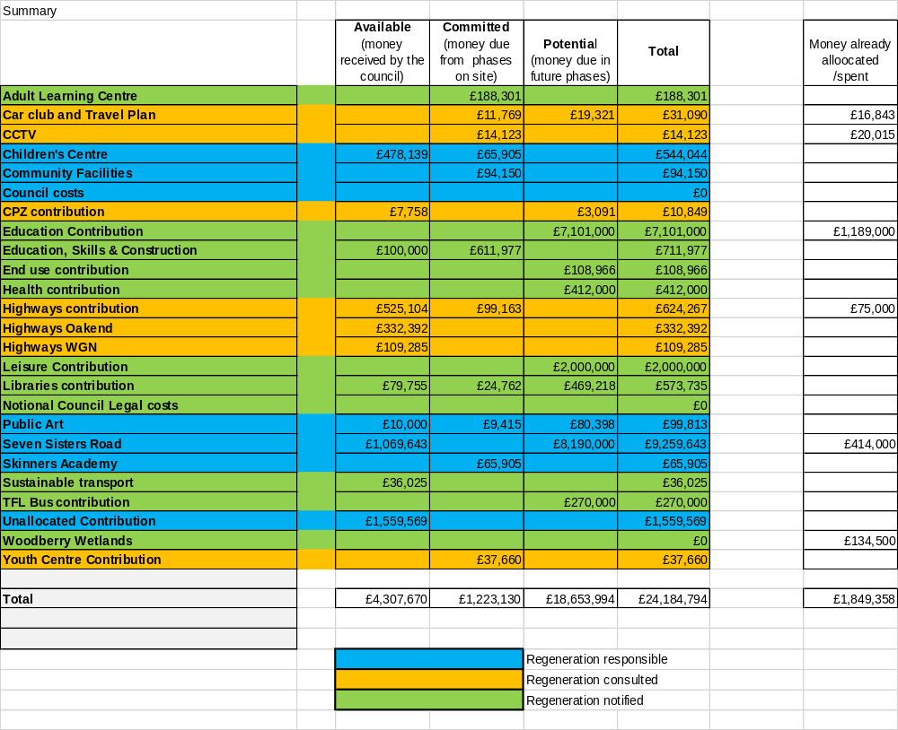

- Proposal for Allocation of contributions
4.1 The existing process.
The approval of S106 contribution allocation follows the Corporate Programme Review Process (see below). The Development Contributions Officer liaises with the section heads to identify priority schemes for funding. The proposed schemes are submitted to the S106/CIL Corporate Board for approval, go through legal and financial checks and are presented to Cabinet for final approval.
For Woodberry Down projects the schemes have to be approved by the Regeneration Manager prior to submission to the CIL/S106 Board.
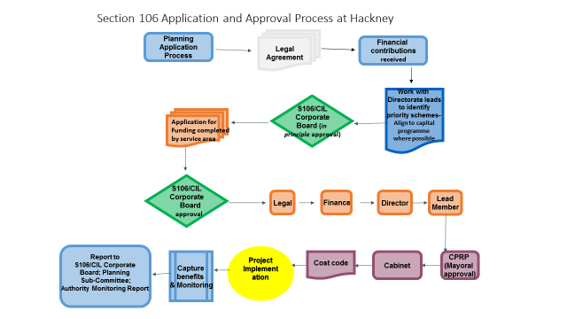
Each S106 Agreement defines the areas where the contributions are to be spent, there are however two agreements where an element of the contributions are not specific:
4.1.1 The Agreement covering KSS2 and 3 (2012/3693) signed in May 2013 defines an ‘Agreed Contribution’ meaning the sum of £1,559,569 to be paid by the Developer to the Council which consists the following:
- Skinners Academy Boundary Environmental Improvement Contribution
- Public Art Contribution
- Adult Learning Contribution
- Children’s Centre Contribution
- Education Skills and Construction Training Contribution
- Libraries Contribution
- Travel Plan Contribution
- Youth Centre Contribution
- Community Facilities Contribution

Of these named elements within the Agreed Contributions funds can be spent on one or all of the elements.

4.1.2 In the Masterplan S106 Agreement (2013/3223) a sum of £1,742,910 has been defined as an ‘Inter-alia Sum’. These monies are to be divided as the Council sees fit for that phase between the other contributions. By the end of the development the amount spent on these should in theory total the amount for each contribution given in the Planning Sub-committee minutes from Feb 2014 (but is not controlled by the legal agreement.) The committee report details the contributions (not already specified in the phase 2 sum) as follows:

- £7,101,000 towards education facilities, to be paid in seven instalments to be determined
- £412,000 towards health facilities within the vicinity of the site
- £2,000,000 towards sport and recreation facilities within the vicinity of the site
- £469,218 towards library facilities

4.1.3 In addition, during the Masterplan review, there was a great deal of discussion about community benefits and it was agreed that WDCO would be responsible for a sum of money (I believe the figure of £100,000 was suggested) to use to benefit the project.

4.3 Framework for Approval.

The Regeneration Manager is currently responsible for signing off all applications for S106 funds at Woodberry Down. Whilst the Regeneration Team should be co-ordinating how the contributions are allocated there are certain projects for which funding will be secured that are not part of the Regeneration Team’s remit, for example funding for highways works or education facilities. The S106 contributions fall within three areas: those that should be approved by the Regeneration Team, those where the Regeneration Team should be consulted and those where the Regeneration Team should be notified. A proposed allocation of these contributions is shown on the table at 3.0 above.

4.3.1 For projects which fall within the remit of the Regeneration Team the following process is proposed.

There is an existing network of meetings both strategic and operational which provide a source for identification of suitable projects for funding. The Regeneration Team will work with these groups to develop proposals to ensure that they meet the conditions of the S106 funding and prioritise those projects which should secure the funding.

Recommended projects will then be submitted to The Round Table for approval prior to presentation to the Development Contributions Officer.

4.3.2 For funding requests which fall outside the Regeneration team’s responsibility they should be reported to The Round Table for monitoring prior to submission to the DCO.

4.3.3 WDCO allocation

£100,000 should be allocated to WDCO from the ‘Agreed Contribution’ in 4.1.1 above. WDCO will be able to propose projects for funding which should be submitted to the Round Table in the same format as the funding requests outlined in 4.3.2 above.

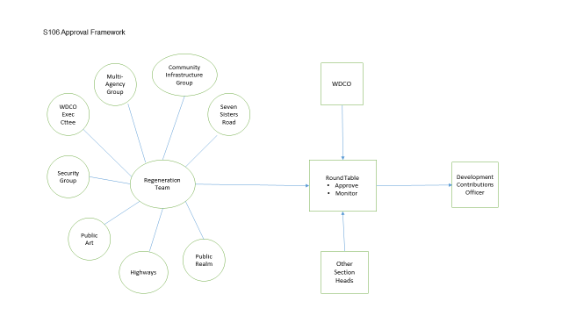

5.0 Recommendations

The Principals have agreed the following:

- The proposed framework for prioritisation of projects
- The framework for approving the allocation of S106 funding
- The proposal for expanding the role of the Round Table to include the responsibility for approving and monitoring S106 Contributions
- The allocation of £100,000 for WDCO

